When to use | On certificate | Logo or pictogram (e.g. on certificate, packaging, label, brochure, etc) | Mark on product
When to use | On certificate |  | Extended | Short
Kiwa marks  on products  in contact with drinking water,  being called:  Kiwa Water Mark | Obliged:  - Kiwa  - Standard #  - Certficate #  Optional:  - text  - pictogram | 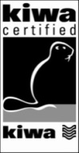  or  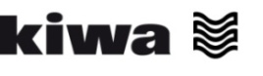  BRL xxxx | 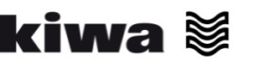 |  or,  after permission by Kiwa,   or KK or KK
Kiwa marks  on products  in contact with drinking water, certified (not on hygienic aspects) upon a former version of a Kiwa evaluation guideline (certificates will lose their validity in the near future),  being called:  Kiwa Keur | Obliged:  - Kiwa  - Standard #  - Certficate #  Optional:  - Text  - pictogram | 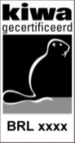  or  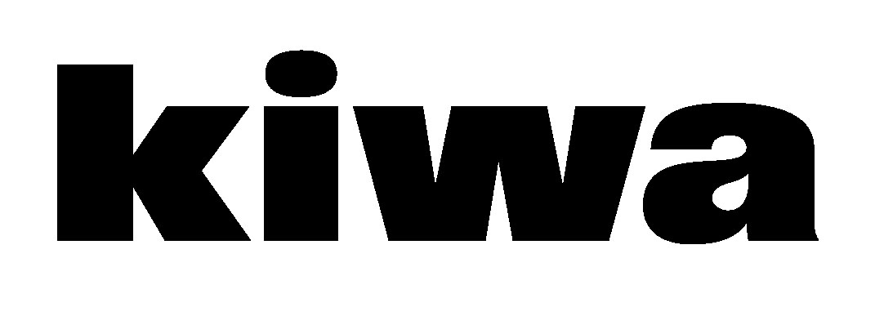  BRL xxxx |  | KK or KK

