We kindly ask you to fill in this application form in its entirety and return. Partial or non-coherent information may cause the issue of a wrong quotation and a subsequent re-evaluation.

COMPANY INFORMATION (mandatory fields)

Company name
Registered office address ________________________________________________________________________ no. _____
ZIP code ___________ City _______________________________________________________ Country _________________
Operating office address _________________________________________________________________________ no. _____
ZIP code ___________ City _______________________________________________________ Country _________________
Telephone________________________ Fax _________________________ E-mail ___________________________________
Contact Person ____________________________________________________Work position _________________________
Shipping address for documentation (reports, certificates etc.):
Address _____________________________no. ____ ZIP code ________ City _____________________ Country __________
Contact person ______________________________________Mail________________________________________________

CERTIFICATION DIRECTIVES/REGULATIONS THE COMPANY IS APPLYING FOR (mandatory data)

☐ BED CE ☐ BED UKCA ☐ BED UKNI
☐ GAR CE ☐ GAR UKCA ☐ GAR UKNI
See Appendix A for nomenclature

CERTIFICATION MODULES THE COMPANY IS APPLYING FOR (mandatory data only in case of issue/update of technical file relative to Dir. 92/42/CEE and Reg. (EU) 2016/426)

Type Examination Annex III module “B“
Product Verification Annex III, par. 5 module “F”
Unit Verification Annex III, par. 5 module “G”

REQUEST DETAILS:

Test report: New Update of report no. ________________________________________
Type of appliance/fitting: ___________________________________________________________________________________
(eg. condensing boiler, air heaters, built-in hob for domestic use, burner control, gas valve, …)
Models name to certify:
Trade mark:
Standard: Voltage supply: ________________________________
Short description of the activity: ___________________________________________________________________________

Type of activity: New appliances/fittings
Extension to other trademarks
Normative update
Update of existing appliances/fittings (components, gas groups, etc.)

If testing is required, go to Appendix B

Surveillance: New surveillance agreement with Kiwa
Update surveillance agreement with Kiwa
If applicable – existing Kiwa Contract Number: ……………..

Combustion and safety tests performed at: Lab. Kiwa Lab. Manufacturer Other ____________________________
Electrical safety tests performed at: Lab. Kiwa Lab. Manufacturer Other ____________________________
EMC tests performed at: Lab. Kiwa Lab. Manufacturer Other ____________________________

Additional requested declaration:
ERP LABELING _________________

Private Labeller list to whom issue the certificate/es requested with this application form:
Private Labeller* | Address
*Private Labeller: It is a company that place on the market under his company name or trade mark products manufactured by a third party. Private Labeller must issue a mandate to the manufacturer to be responsible for Type Approval and Surveillance.

TECHNICAL INFO (mandatory fields):
Declared IP degree: __________________________________ (eg. IPX4D, IP5, …)
Appliance equipped with burner control? Yes No
Appliance equipped with non-CE/UKCA/UKNI certified fitting? Yes No
“Range Rated” appliance? (only for boiler): Yes No
Other:_______________
Requested gas groups:
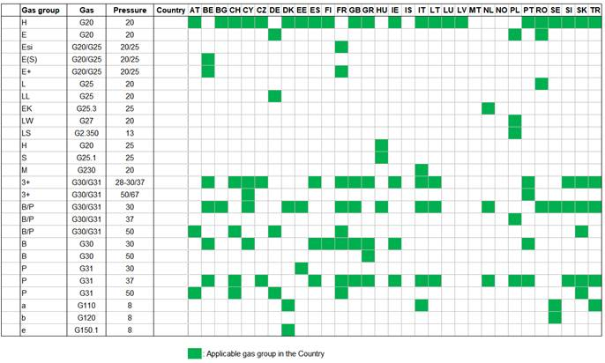

Requested Appliance types:
A₁ | B₁₁ | C₁₁ | C₁₂ | C₁₃
A₂ | B_{11BS} | C₂₁ | C₂₂ | C₂₃
A₃ | B₂₂ | C₃₁ | C₃₂ | C₃₃
 | B_{22P} | C₄₁ | C₄₂ | C₄₃
 | B₂₃ | C₅₁ | C₅₂ | C₅₃
 | B_{23P} | C₆₁ | C₆₂ | C₆₃
 | B₃₂ | C₇₁ | C₇₂ | C₇₃
 | B₃₃ | C₈₁ | C₈₂ | C₈₃
 | B₅₃ | C₉₁ | C₉₂ | C₉₃
 |  |  | C₁₀
 |  |  | C₁₁

DOCUMENTATION NECESSARY TO ISSUE THE QUOTATION (mandatory data – to be attached)

- List of appliances divided into their reference families

The CE Certificate service may be delivered by the following Kiwa location:
Kiwa NL - Wilmersdorf, 50 (PO Box 137, 7300 AC), 7327 AC APELDOORN
Kiwa IT - Via Cadriano, 23, 40057 - Cadriano di Granarolo (BO)

The UKCA and UKNI service will be delivered by the following location:
Kiwa UK - Kiwa House, Malvern View Business Park, Stella Way, Bishops Cleeve, Cheltenham, Gloucestershire, GL52 7DQ

Date ________________

Stamp and signature of the Representative of the Company (by consensus) …….………………………………………………..……….

Appendix A
BED CE - Directive 92/42/EEC
GAR CE - Regulation (EU) 2016/426
BED UKCA - Ecodesign for Energy-Related Products Regulations 2010, SI 2010 No. 2617, as amended
GAR UKCA - Gas Appliances Regulation (Regulation (EU) 2016/426 as brought into GB law and amended), and the Gas Appliances (Enforcement) and Miscellaneous Amendment Regulations 2018 No 389
BED UKNI - Boiler Efficiency Directive (92/42/EEC) as amended
GAR UKNI - Gas Appliances Regulation (Regulation (EU) 2016/426) implemented in Northern Ireland by the Gas Appliances (Enforcement) and Miscellaneous Amendment Regulations 2018
LVD - LVD (2014/35/ EU)
Machinery Directive - Machinery Directive (2006/42/CE)
RED - RED (2014/53/ EU)
EMC - EMC (2014/30/EU)
Appendix B
Type of test: Combustion and safety tests
Electrical safety (EN 60335-1 + EN 60335-2-102):
Minimum requirements of GAR excluding pt. 19.11.4 (EMP)
Minimum requirements of GAR including pt. 19.11.4 (EMP)
Complete test according to LVD or Machinery Directive or RED or EMC
IP test
Other: __________________

à Only for boiler and water heater:
Central Heating efficiency:
Full Load 80/60°C Full Load 50/30°C Part Load
Domestic hot water efficiency tests (EN 13203-2): …..……….. (specify tapping profile)
ERP electric consumption
Stand-by losses
Sound power measurements (L_{WA})
Other ……………………………………………………………………………………………….

